Use Case Name: Database

# Description:

This use case diagram begins when customer click on feedback button.The user can given the feed back .they an give the feed back about some specific area or about the overall performance.Which be read by the admin and they can give reply. .

# Actors:

* Admin
* User.

# trigger:

### When the user click on the feedback button..

# preconditions:

### The user must be logged into their account

# basic FLOW :

1. User click on the feedback button
2. Feedback page will open
3. They can type their feed back and they can also tell their rating for the services.
4. The admin will read the feedback.

# Alternates:

NO

# Exceptions:

When there is a buffer time error or the server connection might get lost or the input is other than the required.

# postconditions:

### The message will be delivered to the admin.

# Stakeholders:

NIL.

# Noun-Phrases Identified:

### user,name,feedbackpage,admin,,adname,rating,feedback.

# conceptual class:

### user,feedbackpage,admin

# Object diagram:

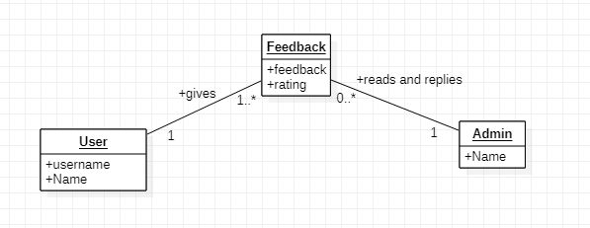

# Sequence diagram: